Printing to Plotters 101:

1. Organize your documents to the appropriate size and export to pdf
   * Plotter is 36” wide
2. Either save your file to a USB drive and bring into the print lab or submit your print job via web print (if you have the plot center drivers downloaded)

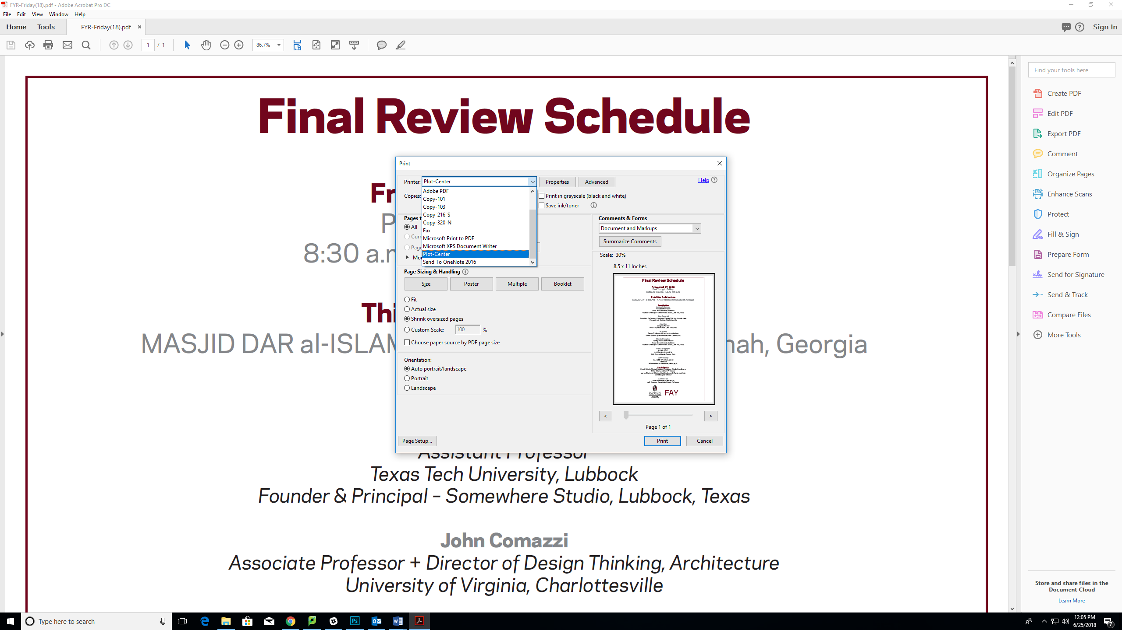

* + When printing select Plot-Center

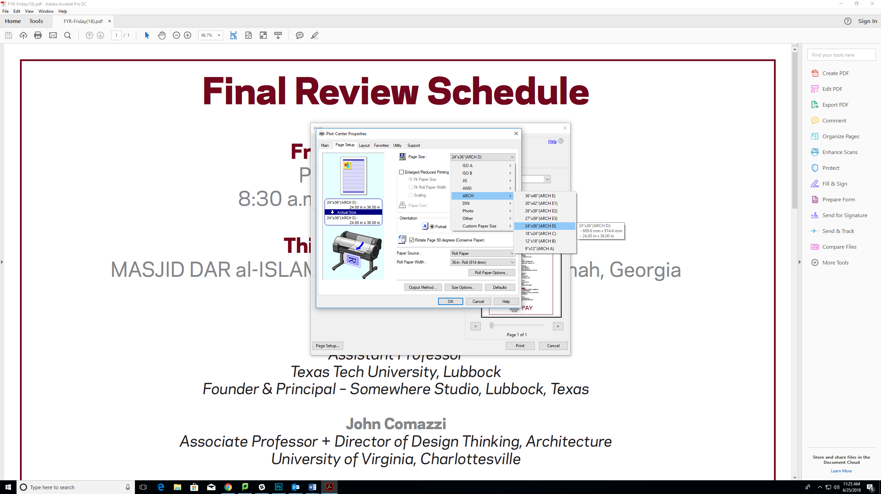

* + Notice the page setup in the printer properties. You can select the size of your document and even rotate it 90 degrees to utilize paper.

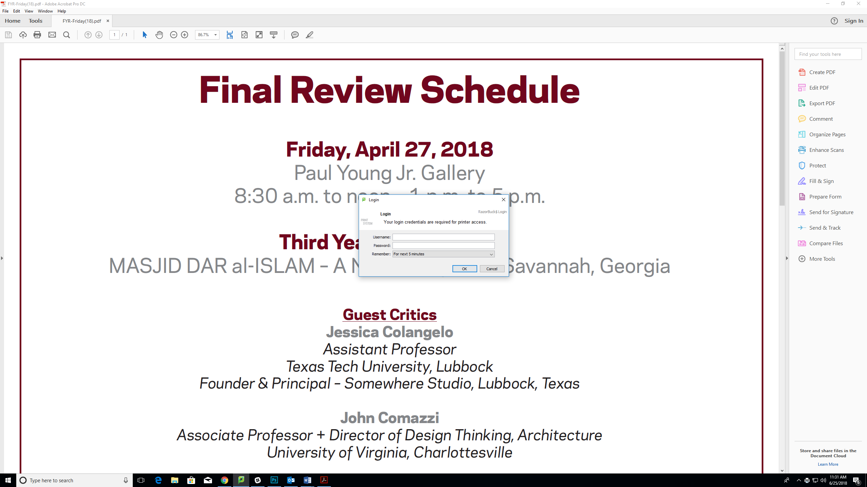



* + You will be asked for your University credentials and get shown the cost of the print job

1. Once in the print lab (041) go to the touch screen and enter/swipe your University ID

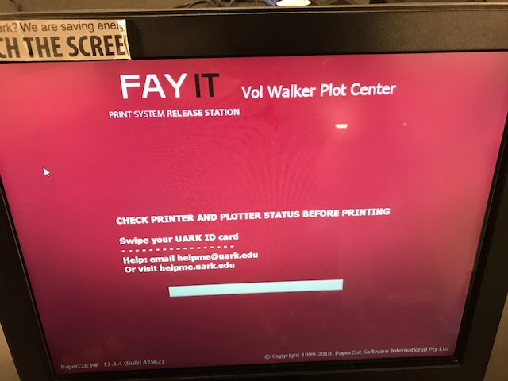

1. Select what print job you wish to complete, notice the charges, and release to printer

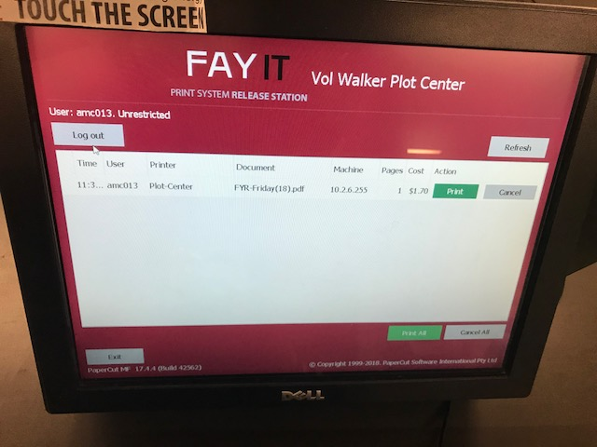

Helpful Tips:

* <https://www.wordpressua.uark.edu/archlabs> is the site for Arch Labs. We have links and advice for printing available as well as the Print Lab hours.
* Test print: Before sending the final print document, copy it and scale it down to test. Vector data, linked files, formatting errors, and extraneous layer information (the most likely sources of plotting issues) will be retained, but the test print will only cost a few cents – allowing you to identify and eliminate problems before the final output.
* Simplify your files by flattening, don’t link images, reduce the resolution (Acrobat Pro PDF is auto set at 1200 dpi, anything above 600 dpi are unnecessary and cause your plot to take 2 – 3 minutes longer).
* Send print jobs 1 page at a time. This allows for you to notice if the formatting has an issue or if lines are not dark enough before everything is processed.
* Many of our plotters and printers have hard file size limits. Documents exceeding 150MB will be discarded. A properly created PDF/X document will fit within this limit and print effortlessly, regardless of the complexity and graphic detail of the originally created document.
* Multiple smaller pages can be formatted in pdf to be printed on one large print job.
* If you need to sheet feed, please see Print Lab team members.
* If you have any questions or problems, please ask a TM or email [helpme@uark.edu](mailto:helpme@uark.edu).