Instructions to download printer drivers:

- Connect to UARK Wi-Fi OR via Ethernet

- Click Box download
- Box is a file storage manager where you can share and collaborate with faculty and students with Uark credentials. Log into your account and a ‘Printer Driver Install’ folder should open with a file called FAY-PlotCenter.exe.
- Download the file and complete the installation process. You can continue with the process while the download is running.
- Go to File Manager

- Enter \\gutenberg in the browser

- Select copier (for 3rd floor studio use Copier-320) ***Download will start to process once clicked but will not show a window until completed. If you click multiple times you will get an error, but it will still install and is ready to use once Print Jobs box opens.

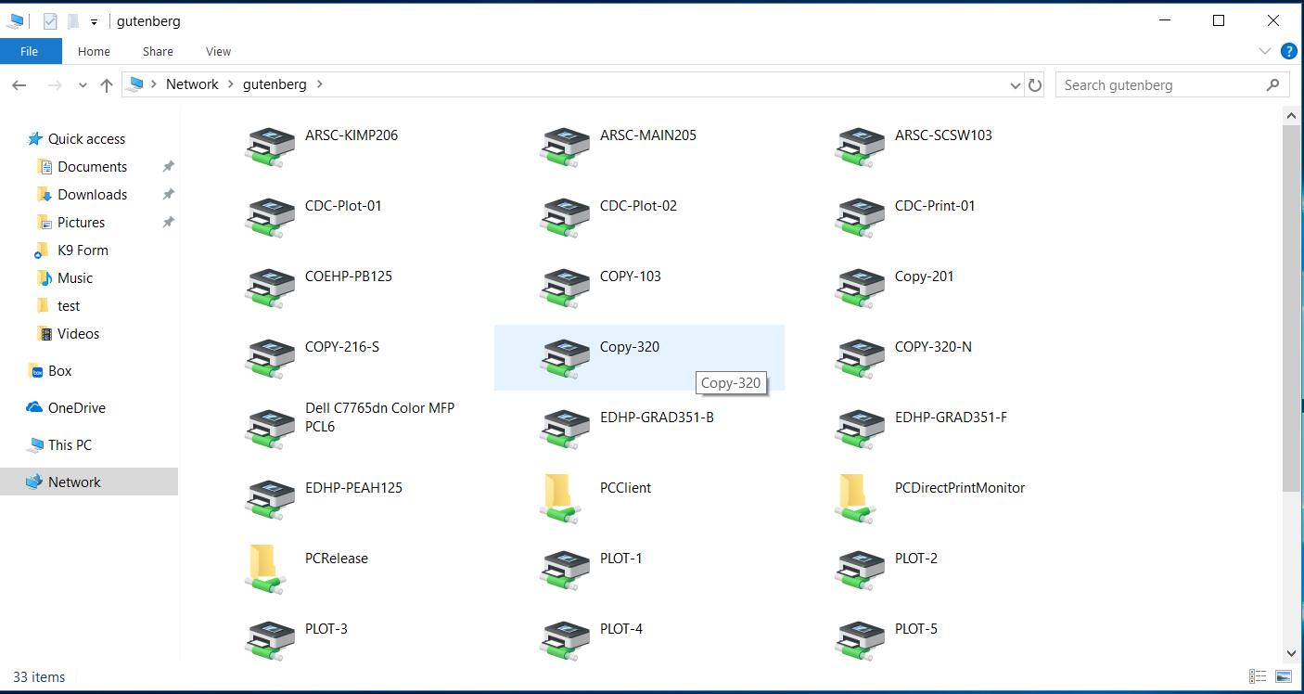
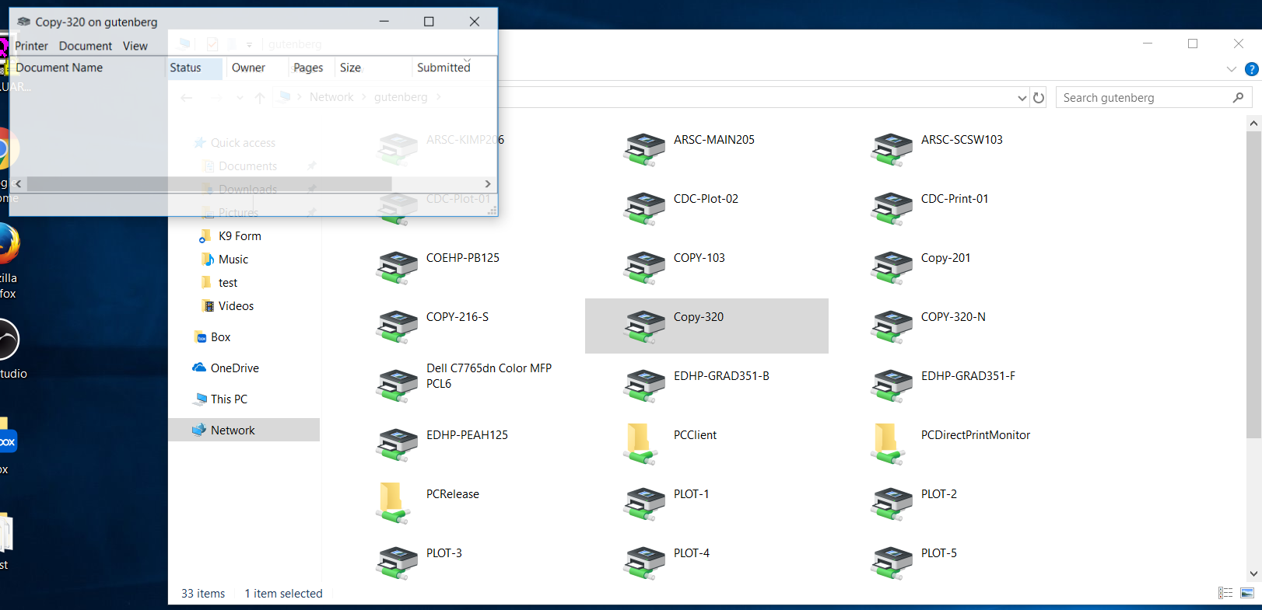

You’re done! If you have any questions, contact IT in Lab 041.

